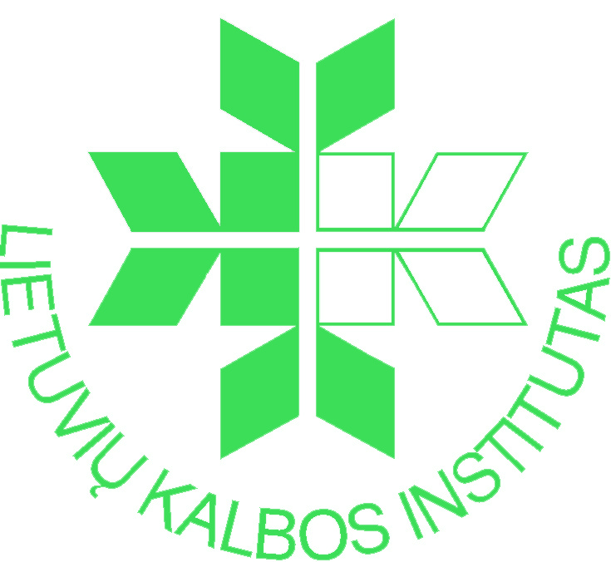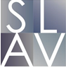

The Institute of the Lithuanian Language and the Institute of Slavic Studies of the Polish Academy of Sciences have pleasure to invite You to the international scientific conference
Interaction of Languages and Cultures in Europe: Border and Contact Areas.
The conference will be held at the Institute of the Lithuanian Language, P. Vileišio str. 5, LT-10308 Vilnius, on 9-11 September, 2020.
The increasingly dynamic processes of linguistic and intercultural contact taking place in different parts of Europe present new challenges for researchers. We invite scientists to discuss methods of modernization of instruments used for border studies, not only describing the Slavic-Baltic border regions, but also to compare research results with outcomes on interaction between modern languages and cultures.
The subject matter includes an innovative look at the problem of contact description in Europe, new terminological and methodological suggestions, and new research paradigms:

- Migration processes, their stability and change in language and culture
- Erosion of language barriers in the context of multilingualism and multiculturalism
- Use of active and passive competences in intercultural contacts
- Communication situation of national and regional languages in the context of globalization
- Linguistic and cultural contacts in urban space
- Investigation of functioning, change and interaction of local linguistic variants
- History of language and intercultural interaction: research methods and sources
- Interaction of languages and cultures in the Grand Duchy of Lithuania and Prussian
Lithuania
- Expression of written language and cultural interaction in the 16th-19th centuries
- Expression of language contacts in onims
- Baltic-Slavic contacts in time and space
- The world of dictionaries and dictionaries of the world
- The new definition of language contact concepts and new terminology

We kindly ask you to send the filled participant form together with the annotation of about 300 words (in Lithuanian, English, Polish, German or Russian) to e-mail: languages.cultures.conference@gmail.com by April 20, 2020.
The confirmation of Your participation will be sent by e-mail May 20, 2020.
ENTRY FEE: EUR 50 (payable by July 1, 2020), EUR 70 (payable by August 15). Your payment information will be provided alongside with the confirmation of Your acceptance.
DURATION OF EACH PLENARY PRESENTATION: 30 min.
DURATION OF OTHER PRESENTATIONS: 20 min.
CONFERENCE LANGUAGES: Lithuanian, English, Polish, Russian, German.
PUBLICATION
Articles based on the presentations (written in Polish, English or Russian) will be available for publication in the journal Acta Baltico-Slavica (No. 45 of 2021) on the electronic platform of the Institute of Slavic Studies of the Polish Academy of Sciences (https://ispan.waw.pl/journals/index.php/abs/) by October 15th. Requirements for publications can be found on the journal website (About the Journal → Author Gudelines). Articles will be reviewed in accordance with specifications and requirements of the journal.

On behalf of the Scientific Committee –

Prof. Habil. Dr. Danguolė Mikulėnienė Prof. Habil. Dr. Anna Zielińska

On behalf of the Organisation Committee –
Dr. Vilija Sakalauskienė Dr. Habil. Zofia Sawaniewska-Mochowa

