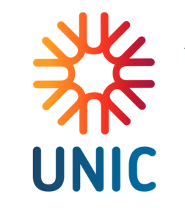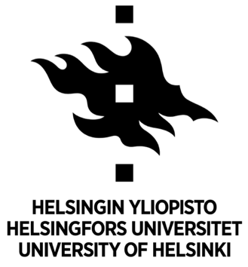
DIALOGUE – MONOLOGUE – SILENCE
International Conference
15–16 April 2027

Call for Papers
Department of Literature, Culture and Communication of The Institute of East European Studies (University of Lodz), in cooperation with the Department of Modern Languages and Literatures (University of Ottawa, Canada) and Slavic and Baltic languages and cultures Department of Languages Faculty of Humanities (University of Helsinki, Finland), invites researchers in literary, cultural studies, linguistics, translation studies, history, and philosophy to participate in the international conference: DIALOGUE – MONOLOGUE – SILENCE. The upcoming conference aims to explore the complex dynamics of dialogue, monologue, and silence in contemporary culture and history.

In our time, the clash of opinions expressed through social networks, media channels, and political discourse has reached an unprecedented intensity. Mutually exclusive viewpoints often compete for monological dominance, resulting in the erosion –or even disappearance – of genuine dialogue. This global phenomenon manifests itself in diverse ways across different societies and cultural contexts.

Writers, artists, and theatre as well as film directors have increasingly addressed this crisis of dialogism, offering rich material for the analysis of profound human experiences and the ethical dimensions of communication. At the same time, it remains essential to examine how dialogue, monologue, and silence have functioned throughout history and how these forms of expression shape our understanding of culture, identity, and community.

Conference topics may include:
(but are not limited to)
- Dialogism and monologism in literature, theatre, cinema, and the arts
- The role of silence as a communicative or ideological strategy
- Dialogue of cultures and intercultural communication
- Ethical dimensions of speech, listening, and silence
- Digital communication and the crisis of dialogue in the modern world
- Historical perspectives on dialogue and its transformations
- Philosophical and theoretical approaches to dialogism
- Women’s silence: between experience, oppression, and emancipation

The conference will take place at the Faculty of Philology building, University of Lodz, 171/173 Pomorska Street, Lodz. The conference will be held in a hybrid format.

Working languages:
Polish, English, Russian, Ukrainian.

Conference registration fee 100 EUR. The bank account number will be provided in the next letter.

The organizers offer the possibility of publishing articles free of charge in the international scholarly journal Acta Universitatis Lodziensis. Folia Litteraria Rossica, as well as coffee breaks.

Other costs are to be covered by the participants themselves.

Important dates:
• Abstract submission deadline: June, 30 2026
• Notification of acceptance: September, 30 2026
• Conference dates: 15–16 April 2027

Contact:
Conference applications should be submitted via the following link: https://forms.office.com/e/WVcWBx82Bg

For any questions, please feel free to contact us by email at: konferencja2027@filologia.uni.lodz.pl

Follow the conference website: www.isw.uni.lodz.pl/dialogue

We look forward to your contributions and to an engaging interdisciplinary dialogue!

Organizing Committee of the Conference

Aleksandra Szymańska, Ph.D., The Institute of East European Studies, Department of Literature, Culture and Communication, University of Lodz, Poland
Ewa Sadzińska, Ph.D., The Institute of East European Studies, Department of Literature, Culture and Communication, University of Lodz, Poland
Piotr Baleja, MA, University of Lodz Doctoral School of Humanities, Poland

Academic Committee of the Conference

Zofia Brzozowska, Professor, Director of the Institute of East European Studies, Department of Literature, Culture and Communication, University of Lodz, Poland

Douglas Clayton, Professor Emeritus, Department of Modern Languages and Cultures, University of Ottawa, Canada

Tomi Huttunen, Professor, Head of the Slavic and Baltic Languages and Cultures, Department of Languages, Faculty of Humanities, University of Helsinki

Natalia Vesselova, Adjunct Professor, Department of Modern Languages and Cultures; Department of Classics and Religious Studies, University of Ottawa, Canada

Anna Warda, Professor, The Institute of East European Studies, Department of Literature, Culture and Communication, University of Lodz, Poland

