Below is a list of Israeli Universities/institutions of higher learning that offer emergency fellowships for scholars/students from Ukraine. The list will get updated as more universities and departments join in every day. There are also several individual scholars or labs that are willing to offer fellowships. I will update the list when I get more info from them. You can also contact me directly and i will do my best to help you navigate the system: innale@openu.ac.il

- Tel Aviv University – Emergency Scholarship for Research Students from Ukraine Call for Applications
https://international.tau.ac.il/scholarship_programs?fbclid=IwAR0ZPZHasUhxY7jSdopu-BNv99Qt8sSCwW4CL8stw7tTipnW7fO_mheVtok
In the name of academic freedom and in solidarity with the Ukrainian people, Tel Aviv University (TAU) established an emergency fund to support research students from Ukraine. TAU is offering to host up to 20 research students from Ukrainian universities in all disciplines for a full semester at TAU. During their stay at TAU, scholarship recipients will have the opportunity to further their research through collaboration with TAU’s leading scholars and scientists.
Program Outline
- The program is intended for Postdoctoral students, PhD students, and research-track MA\MSc students currently enrolled in a university in Ukraine in any discipline.
- Students must be Ukrainian citizens to apply.
- Students must be able to communicate effectively in English.
- Scholarship recipients will be invited to come to TAU soon after notification of acceptance and to remain for up to six months.
- The university will match each scholarship recipient with a TAU faculty member who will serve as the student’s mentor while at TAU.
- The scholarship will cover full tuition and a stipend.
Application
Please email the following material to Ms. Michal Linder at TAU International - Intlprojects@tauex.tau.ac.il
- 1-page (up to 500 words) statement describing research.
- Letter of recommendation from advisor.
- Document showing active status at home university in Ukraine.
Deadline
Applications will be considered on a rolling basis effective immediately and until further notice.

2. Feinberg Graduate School at the Weizmann Institute of Science – Supported visiting students and postdocs program for Ukrainians

https://www.weizmann.ac.il/feinberg/supported-visiting-students-and-postdocs-program-ukrainians?fbclid=IwAR3BY6mZeWZXu6E2QlJDAgeih5BI7IgU1F0XhWr_jraHtHOWurIWi6bj18M

Институт Вайцмана принимает студентов последних курсов института-магистратуры, аспирантуры и научных сотрудников разных дисциплин из Украины. Программа рассчитана максимум на полгода, есть жилье, помощь с билетами и стипендия. Необходимо предоставить резюме, форму (смотреть по ссылке), оценки и копию паспорта. С вопросами можно обращаться к координаторам по дисциплинам (указано по ссылке) на ангилийском языке, или к Яне (+972545680153, ватсап) на русском. Студентами с неполными заявлениями (например, не имеющим возможности предоставить выписку с оценками), стоит тоже подать документы на рассмотрение.

The Feinberg Graduate School at the Weizmann Institute of Science invites advanced undergraduate, graduate students, and postdoctoral researchers to apply to our supported Visiting Students Program. The program welcomes students from Life Sciences, Mathematics & Computer Science, Chemistry, Physics, and Science Teaching to apply. Visitors will be hosted at one of our labs and will get monthly support of 5000 NIS for up to six months + accommodations + airfare.
Please contact our program coordinators given below to apply or obtain more information. The application material should include, if possible:
· CV: Your CV should include information about prior experience with experimental or theoretical research, where relevant.
· Copy of your passport (i.e., copy of the page that displays your details and photo).
· Transcript (with your university's logo): You should submit an official transcript signed by the appropriate authority at your university.
· Up to one page of a personal note about yourself and your academic aspirations and scientific interests.
· Please complete the table below

We understand that you might not solicit all the above material, so we would consider your application even if you have only part of the above material. We plan to do everything that we can to expedite the acceptance procedure. Once the application has been processed, our board of study for each discipline would assist you in finding a host faculty (PI) closely related to your field of research or interest.

The list of coordinators appear on the website. Alternatively, you can also write directly to the Head of our International Office, Aileen Halbershtat aileen.halbershtat@weizmann.ac.il, for further assistance.

3. Ukraine Emergency Fellowship at U of Haifa, preference for female scholar with children in Humanities, Social Science, or Law

Ukraine Emergency Fellowship at the Haifa Center for German and European Studies of the University of Haifa

We are offering one one-year fellowship in residence at the Haifa Center for German and
European Studies for one scientist from Ukraine with a background in the Humanities,
social sciences or law (with a doctorate). The fellowship holder should work on aspects of
modern European history and have a conversational command of English. We will be
flexible concerning the scope and area of studies (Europe in its wider dimensions).
Preference will be given to female scientists who had to flee the country with their
children.

Starting date: as soon as possible

The fellowship will include the flight as well as a stipend of 30.000 US dollars for the year.
The fellowship is paid by funds of the German Academic Exchange Service – the DAAD –
and the personal funds of the head of the center. We hope that others around the world
will follow our example and give these people in need a home from where they can
regroup in dignity, continue their careers, and can continue to be part of the academic
and social leadership of Ukraine, if only from a safe distance.

If you are interested and think you might meet the criteria, please contact us at
hcges@univ.haifa.ac.il.
* This fellowship does not confer refugee status! We will have to obtain a regular visa for
post-doctoral fellows.

4. The Ben-Gurion University of the Negev 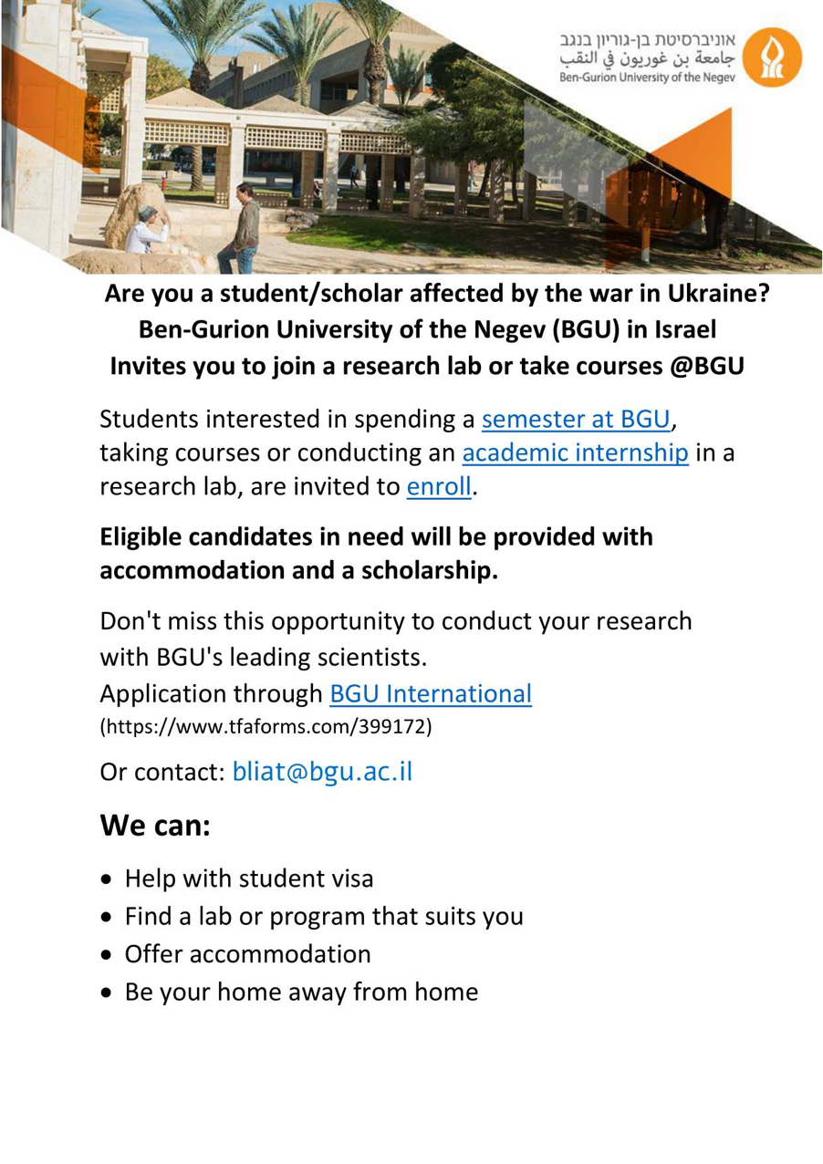

5. The Hebrew University of Jerusalem

